
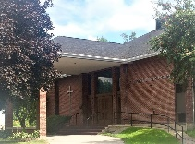
The United Church of Canada
L'Église Unie du Canada
St. Andrew’s United Church

188 Wellington Street. Miramichi, NB. E1N 1M4
Telephone: 506-773-9932
Church Email: St_Andrews1@outlook.com

Sunday, October 11, 2026 20th Sunday after Pentecost

St. Andrew’s United Church is a Christian community that shares Christ’s love through worship, fellowship, spiritual growth, and outreach.

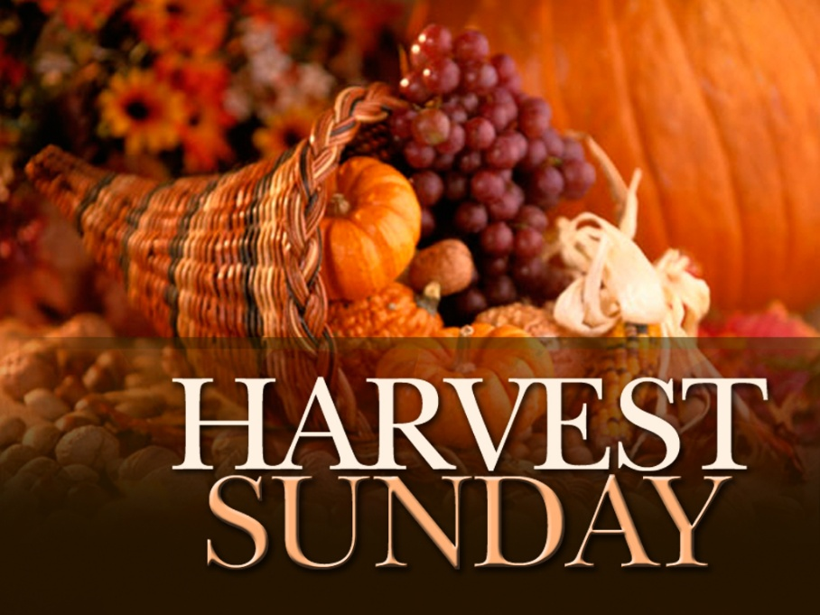

Worship Leader: Rev. Kathy Parks

Organist and Choir Director: Lois McKinnon

Music Provided by: St. Andrew’s United Church Choir

Greeter: Bev Campbell & Muriel Lamkey
Sunday Worship Service

* Indicates to stand as you are able.

Prelude
We Gather Before God

Welcome

Memorials & Announcements – Holly Daley

Introit: MV #18, “Lord, Prepare Me to Be a Sanctuary”
Lord, prepare me to be a sanctuary,
Pure and holy tried and true;
with thanksgiving,
I’ll be a living sanctuary for you.

Light the Christ Candle: Brenda Hicks
We seek God’s presence in our lives today.
We see God’s Spirit moment by moment in worship.
As we journey in faith, we strive to move forward in faith.
We will never turn back, except to give thanks.
And so we welcome the guiding light of Christ.
-Elaine Bidgood Sveet, Minot, North Dakota

As we light the candle we sing: VU # 313, vs. 1 “God, Whose Almighty Word”
God, whose almighty word
chaos and darkness heard, and took their flight,
hear us, we humbly pray, and where the gospel day
sheds not its glorious ray, let there be light.

Gathering Prayer

Gathering Hymn: VU # 516, “Come, You Thankful People, Come”

CALL TO WORSHIP (responsive)
Here in this place, with these people, we come to worship the living God.
In you, O God, we hope; in you, Creator of love, we live.
Here in this sacred space, in these very moments, we are invited to the Table of Joy.
In you, Christ of the Way, we rejoice; in you, dear Brother, grace is as near as your heart.
Here on this day of gentleness and beauty, we are filled with the peace of God.
In you, O Spirit, we find our path; in you, Teacher of hope, we learn to serve.

Hymn: VU # 519, “Sing to the Lord of Harvest”

Prayers of Adoration, Confession and The Lord’s Prayer

Assurance of Pardon
While it is true we have all sinned, it is a greater truth that we are forgiven through God’s love in Jesus Christ. So be at peace with God, with yourself and with one another. Amen

We Listen for God

Family Time

Anthem: “Creator God, You Gave Us Life”

Prayer for Understanding (in unison) – Patricia Boucher
God of prophets and parables, we gather to listen to the Scriptures read and proclaimed. By your Spirit, grant us fresh understanding, and challenge us to live according to your transforming grace. Amen

Scripture Readings

Deuteronomy 8:7–18 God will bring you to a bountiful land.

Psalm 65 (VU pp. 782–783) God provides; the valleys shout and sing.

2 Corinthians 9:6–15 God loves a cheerful giver.

Luke 17:11–19 Ten healed; one returns to offer thanks.
- Rev. Kathy

Message

We Respond to God

Offertory Invitation

Offertory Response: VU # 549 “For All Your Goodness, God”
For all your goodness, God,
We give you thanks.
Thanks for the food we eat,
And for the friends we meet;
For each new day we greet,
We give you thanks.

Offertory Prayer:
Your gifts have been showered upon us but your gifts are not for ourselves alone. Your gifts are meant to be shared, a response of love, joy, and generosity. Bless these gifts, and bless the givers and the recipients so that we may all know your love and grace. Amen.
-Beth W. Johnston Springhill, NS

Praise before Prayer: “Gather Us In”
Gather us in, ground us in you.
Gather us in, ground us in you.
Gather us in, gather us in,
ground us, ground us in you.

Prayers of Thanksgiving & Intercession

Hymn: VU # 517, “Praise God for the Harvest”

Benediction

Choral Benediction:
Thank you, Lord, on this day, for our many good blessings.
Thank you, Lord, on this day, for our many close friendships.
Glory to God, may you hear our prayer.
Guide us on forever.
Thank you, Lord, on this day, for our blessings and
friendships.

Postlude

Announcements

The sympathy of the congregation is extended to Ron & Ann Carter and Ray & Janice Carter and their families on the death of their brother, Roy Carter of Moncton, NB.

Memorials:

In loving memory of Caleb Cope, donations to Local Funds have been received from Dave & Brenda Hicks, Karen & Paul Rose.

In loving memory of Donna (Dickson) Yeaman, a donation to Local Funds has been received from her Family.

In loving memory of Roy Carter, donations to Local Funds have been received from Jeanne Breau, Karen & Paul Rose.

In loving memory of Ron Morrison (June 7, 1941 – October 11, 2017), a donation to Local Funds has been received from his Wife, Shirley Morrison and Sons, David & Kevin Morrison.

- Worship Leaders: Oct. 11 – Rev. Kathy Parks/Oct. 18 – Rev. Kathy Parks

▪ Greeters: Oct. 18 – Margaret & Benjamin Glidden/Oct. 25 – Doris Tozer & Charles Turner

▪ Sound System: Oct. 11 – Don Bowman/Oct. 18 – Barry Campbell

▪ PowerPoint: Oct. 11 – Barry Campbell/Oct. 18 – Jennifer Walker

-Offering Collectors: Oct. 11 – Bev & Barry Campbell, Holly Daley, Judy Donnelly/Oct. 18 – Patty Deitch, Cynthia Duplessie, Dennis & Judy Morrison

▪ Offering Counters: Oct. 11 – Carol Johnston & Karen Rose/Oct. 18 – Judy & Dennis Morrison

2. Weekly Collection:
Collection on Sunday, Oct. 4th $ 1,010.00
Weekly Par Collection $ 1,475.53
Total for Week of Oct. 4th $ 2,485.53

This Week:

Tuesday, Oct. 13th – 1:30 p.m. – Faith & Spiritual Development

Tuesday, Oct. 13th -3:00 p.m. – Property & Financial Management

Upcoming:

Christmas Shoebox Campaign
Our annual campaign begins next Sunday, Oct. 18. Filled shoeboxes must be returned no later than Wednesday, Nov, 18 for shipping. Bring filled boxes to the office, please. Please note you have to include $12 for shipping with your filled shoebox.

Memorial Candle Lighting
This annual service will be held on All Saints Day, Sunday, November 1st. If you would like to light a candle for a relative or close friend who died in the past year (Nov. 2025 to Nov. 2026) please give, their names to Karen no later than Wednesday, Oct. 28th.

Community:

The 70th Miramichi Folk Song Festival presents the annual Remembrance Dinner Theatre & Song at the Kin Centre on Sunday, November 1, 2026. Dinner begins at 5pm followed by short drama presentations by the MVHS Drama Club and songs by the Villagers, Susan Butler, Dwayne Drost and Gerry Roberts. Tickets are $45 and must be ordered by October 25th by phone (622-1780) or email <susanbutler867@gmail.com>. Please state any dietary concerns.

The 5th Annual Socktober Campaign…is now running till the end of Oct. A collection box will be at the back of the sanctuary by Karen’s office. “By warming the souls of others, we warm our hearts”

Pastoral Care:

If you need pastoral care, please contact the church office at
506-773-9932, and Karen will arrange it or on her cell at
506-626-4162.

Minute for ecological Justice



United for Ecological Justice: Creation is not simply where we live, it is God’s gift, our shared home, and our sacred
responsibility. As people of faith, we are called to love our neighbors, protect the vulnerable, and care for the earth that
sustains all life. Ecological justice is therefore not only an environmental concern;
it is a matter of faith, discipleship, justice, and love. We invite congregations to join us in becoming United for Ecological Justice; a growing movement of communities committed to listening to creation, learning from Indigenous wisdom,
reducing harm, and taking faithful action for a more just and sustainable world.
Together, let us move from concern to action, from consumption to stewardship, and from fear to hope, building a world where creation can flourish and future generations can thrive. Will your congregation join us? Faith in action. Justice for creation. Hope for generations to come. Hallelujah!

For more information, contact:
Rev Dr Shepherd Munikwa - Minister for Justice Mission & Outreach.
Email: smunikwa@united-church.ca

We can also go to the link for more information.

Website: https://ucceast.ca/justice-mission-outreach-2/justice-ecological-justice

We gratefully acknowledge the dedication of the bulletins
in loving memory of my Father, Alex Milson by Merle Milson and Patricia Boucher.



Online St. Andrew’s United Church
www.standrewsunitedmiramichi.org
www.facebook.com/St.AndrewsUnitedChurchMiramichi

Offering E-Transfer:
standrewswellingtonstreet@gmail.com

